Mail trigger on every successful s3 backup with hostname and file size details document

Create s3 bucket

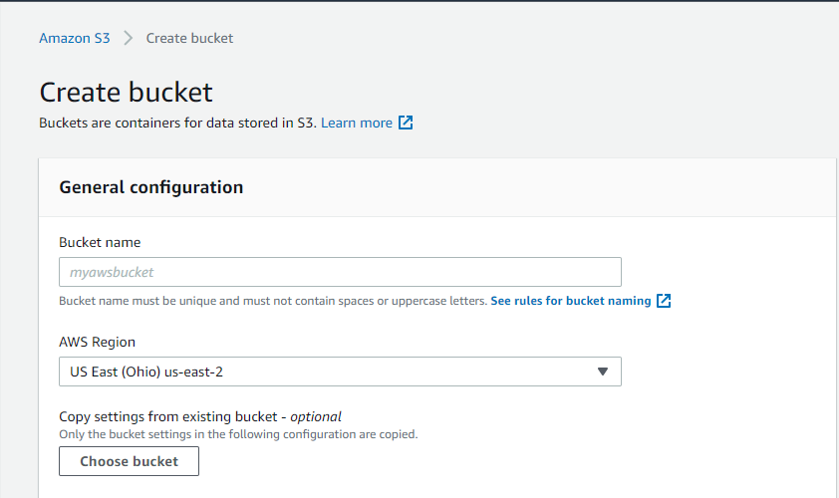

Now create SNS Topic

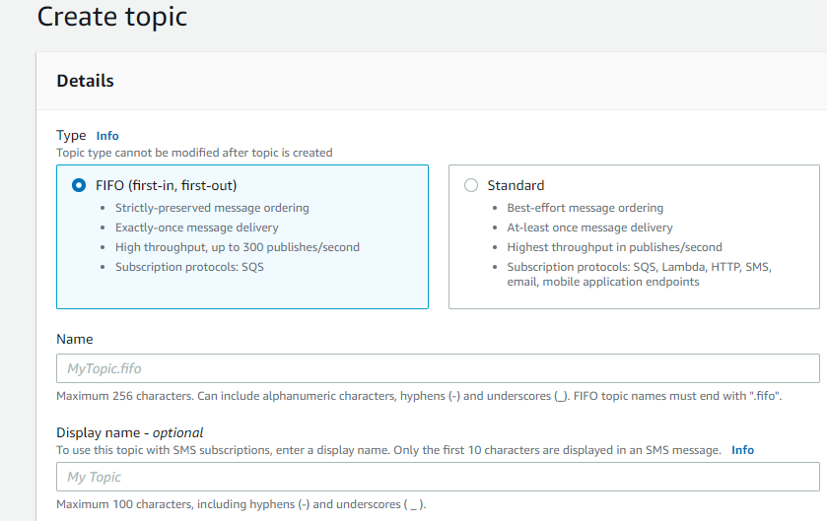

Now Go to the subscriptions and create a subscription of the newly created topic

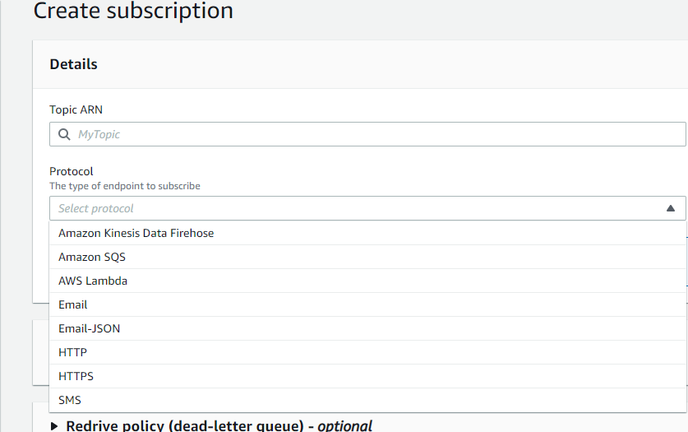

Now select the newly created topic ARN and click on Protocol and select Email for the notification.

Now go to Newly created topic and click on access policy

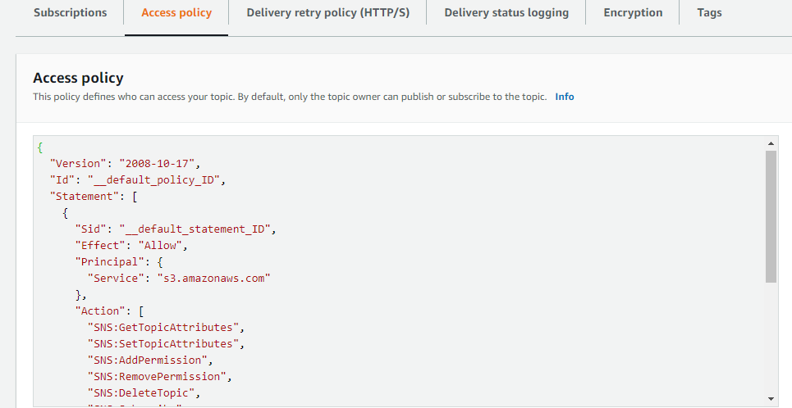

And edit the policy

**Granting Permissions for S3 to Publish Messages to an SNS Topic**

IAM policy that needs to be attached to the destination SNS topic

Now give the SNS ARN and S3 bucket ARN here.

{

"Version": "2008-10-17",

"Id": "example-ID",

"Statement": [

{

"Sid": "s3-event-notifier",

"Effect": "Allow",

"Principal": {

"Service": "s3.amazonaws.com"

},

"Action": [

"SNS:Publish"

],

"Resource": "<UPDATE-YOUR-SNS-ARN-HERE>",

"Condition": {

"ArnLike": {

"aws:SourceArn": "arn:aws:s3:*:*:<UPDATE-YOUR-BUCKET-NAME-HERE>"

}

}

}

]

}

Now go to S3 bucket and click on the newly created bucket and click on properties go to event notifications and select that and create event notification.

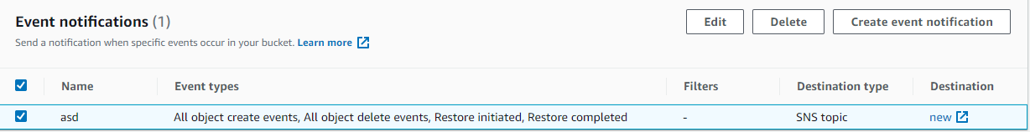

Now give event name

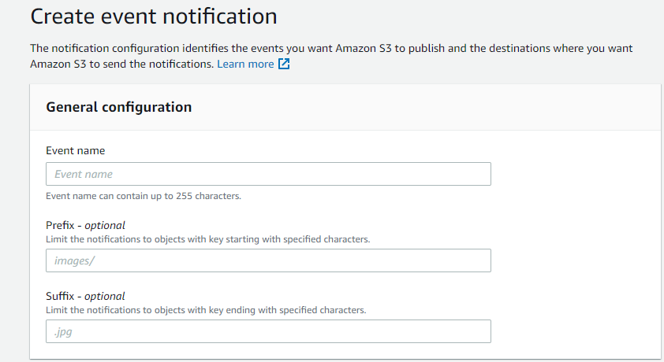

Now select the required event types here

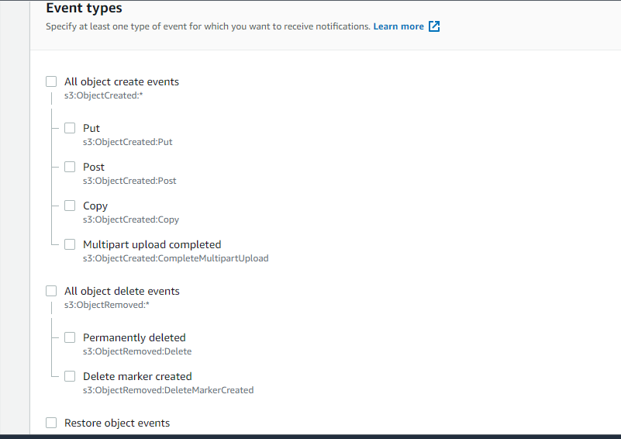

And now give Destination to SNS topic

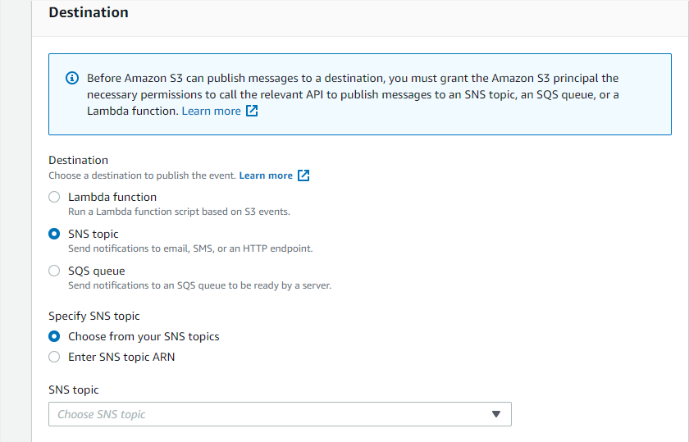

Here to select SNS topic and specify the newly created SNS topic after that click on save changes.

Now if any action is happened on this bucket like create object or delete object it will give a notification to your email and give all the information about the object like size of the file.